

USE CASE 1 — Smart Parking Suggestion
Use Case Name:
UC-1 Smart Parking Suggestion
Primary Actor:
Fan (User)
Supporting Actors:
- AI-Based Crowd Detection System

Goal:
To recommend the optimal parking zone based on the user’s ticket seat information and real-time crowd density.

Preconditions:
- The user has a valid ticket, and seat information is already available in the system.
- The user is logged in (non-functional requirement).
- Stadium seating and parking zone data are available.
- Real-time or cached crowd density data is accessible.

Postconditions:
- The user receives a recommended parking zone.
- The system logs the recommendation event.
- The selected zone becomes available for navigation.

Main Flow:
- The use case begins when the user selects “Find Best Parking”.
- The system retrieves seat information directly from the user’s ticket data.
- The system retrieves real-time crowd density for all parking zones.
- The system evaluates and ranks parking zones based on:
  - proximity to the user’s seat section
  - current congestion levels
- The system selects the optimal parking zone.
- The system displays the recommended zone and alternative options.
- The user confirms the selected parking zone.

Alternative Flows:
A1 — Invalid or Missing Seat Data
- At Step 2, if the seat data cannot be retrieved,
→ the system displays an error and requests the user to re-scan the ticket.
A2 — Real-Time Crowd Data Unavailable
- At Step 3, if live data is unavailable,
→ the system uses cached data and displays a warning message.

Exception Flow:
E1 — System Fails to Generate Recommendation
- If scoring cannot be completed due to missing or corrupted data,
→ the system informs the user that no recommendation can be made and suggests choosing a parking zone manually.

Includes:
- AI-Based Crowd Detection
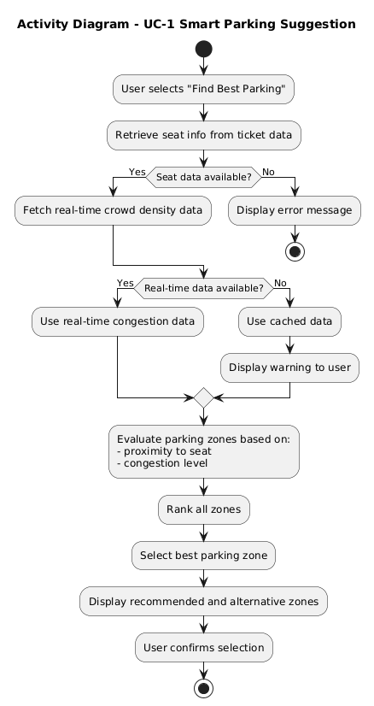
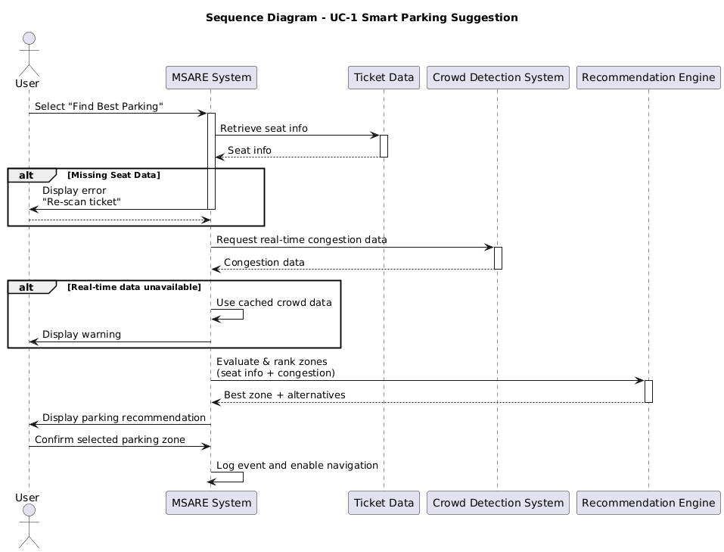
USE CASE 2 — Navigation
Use Case Name:
UC-2 Navigation
Primary Actor:
Fan (User)
Supporting Actors:
- AI-Based Crowd Detection System
- POI/Facility Database
- Indoor Positioning System
- Outdoor Map System

Goal:
Guide the user throughout their entire journey:
- Vehicle Navigation: current location → parking zone
- Fan Navigation: parking zone → stadium entrance → seat
- Reverse Navigation: seat → bookmarked parking location

Preconditions:
- A parking zone has already been selected (from Smart Parking Suggestion).
- Outdoor map data is available for vehicle navigation.
- Indoor map and AR anchors are available for fan navigation.
- The user has granted required permissions (location, camera, orientation sensors).
- For reverse navigation: a parking location must be bookmarked.

Postconditions:
- The user successfully reaches the selected destination (parking zone, entrance, seat, or parking on the way back).
- Navigation events are stored for analytics.

UC-2 Main Flow (Top-Level Navigation):
- The navigation use case starts when the user taps “Start Navigation”.
- The system determines whether the user is in vehicle mode or fan mode based on available GPS accuracy and movement speed.
- The system loads the appropriate map view (outdoor map or indoor AR).
- The system begins turn-by-turn guidance.
- The system continuously updates the user’s position.
- The user follows the instructions until reaching the target destination.
- The system notifies the user upon arrival.

UC-2.1 Vehicle Navigation — Map Navigation
Goal:
Guide the user from their current location to the selected parking zone using a map.
Preconditions:
- The user is outdoors and GPS accuracy is sufficient.
- A parking zone has already been selected.
Postconditions:
- The user successfully reaches the chosen parking zone.
Main Flow:
- The system loads the outdoor venue map.
- The system identifies the user’s current vehicle position.
- The system calculates the optimal driving or walking route to the selected parking zone.
- The system displays the route on the map with turn-by-turn instructions.
- The system updates the route in real time as the user moves.
- The user arrives at the parking zone.
Alternative Flows:
A1 — GPS signal weak/unavailable:
- The system switches to static map mode and instructs the user to approximate movement manually.
Exception Flow:
E1 — Route cannot be calculated:
- System displays “Navigation unavailable” and suggests nearest major landmark instead.
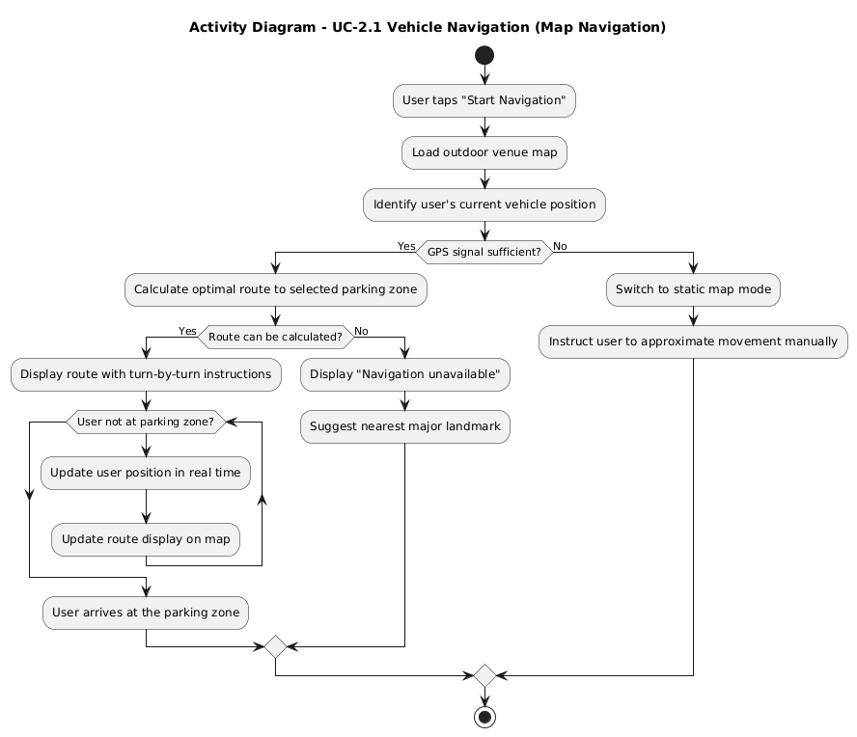
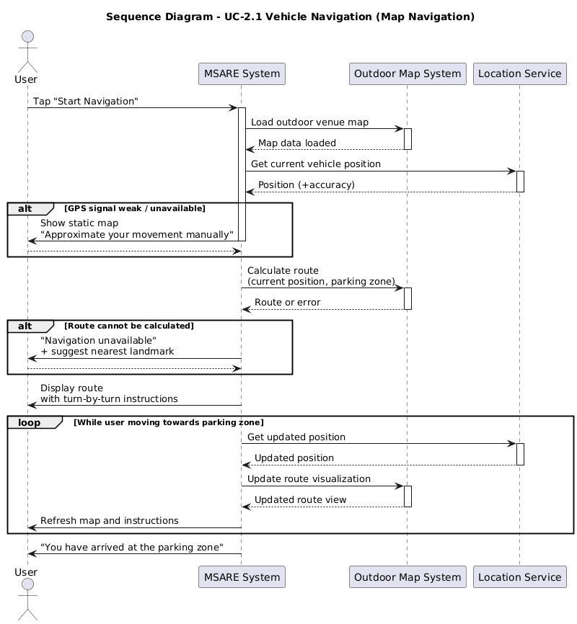
UC-2.2 AR Navigation — Fan Navigation (Parking → Entrance → Seat)
Goal:
Guide the user using AR overlays inside and around the stadium.
Preconditions:
- The user has completed vehicle navigation.
- AR mode is supported and permissions are granted.
Postconditions:
- The user reaches the entrance or seat using AR guidance.
Main Flow:
- The system activates AR mode and initializes the camera and sensors.
- The system loads AR anchors and indoor positioning references.
- AR route overlays (arrows, markers, labels) are rendered on the user’s screen.
- The user views the route through their camera feed and follows the AR arrows.
- The system provides additional cues for:
  - floor transitions (stairs, elevators)
  - turn instructions
  - distance to next point
- The user reaches the entrance and then their seat.
- The system displays an arrival confirmation.
Alternative Flows:
A1 — AR tracking lost:
- System prompts the user to stabilize the phone or re-scan the area.
Exception Flow:
E1 — Indoor positioning offline:
- System falls back to 2D indoor map without AR.
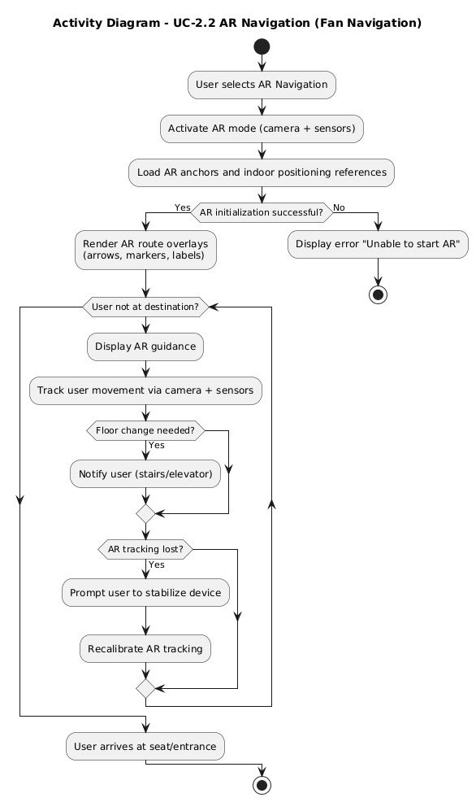
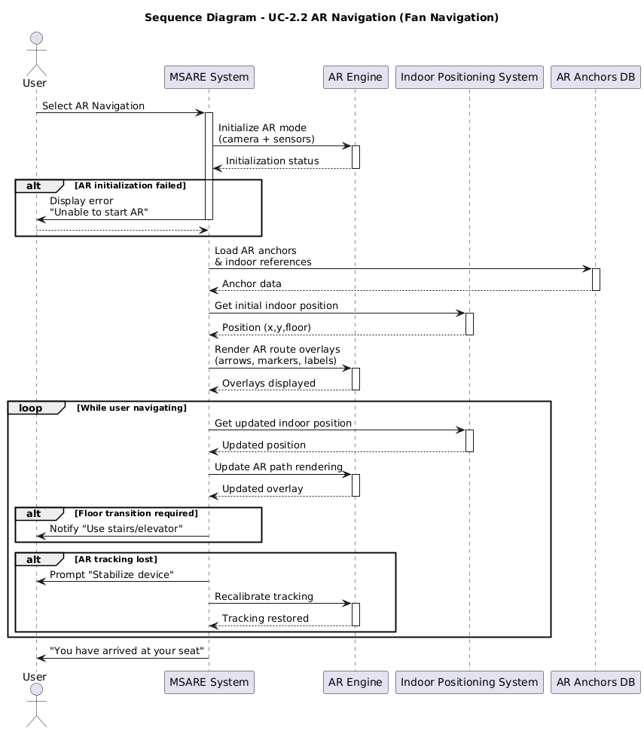
UC-2.3 Optional Stops (Restroom, Shop, Prayer Area
Goal:
Allow the user to add optional intermediate stops in the route.
Preconditions:
- POI data is available.
- User is currently using navigation.
Postconditions:
- The navigation route updates to include selected stops.
Main Flow:
- The user selects “Add Stop” during navigation.
- The system displays available POIs with distance and estimated delay.
- The user selects one or more stops.
- The system inserts the stops as waypoints.
- The system recalculates the route to include them.
- Navigation resumes along the updated path.
Alternative Flows:
A1 — POI closed/unavailable:
- The system marks the POI as inaccessible.
Exception Flow:
E1 — No indoor map data for selected stop:
- System warns the user and does not add the stop.
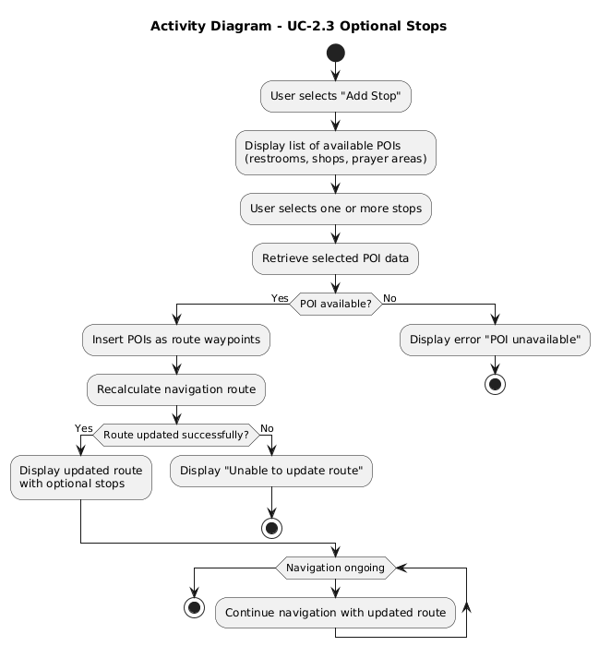
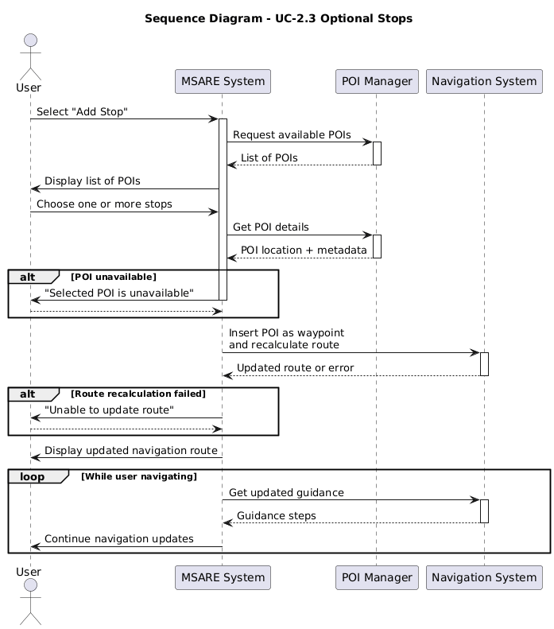
UC-2.4 Route Recalculation
Goal:
Recalculate the navigation route in real time when the user deviates or modifies their route.
Preconditions:
- User is currently navigating.
Postconditions:
- Navigation continues on the new route.
Main Flow:
- The system detects user deviation from the route or detects a new stop added.
- The system recalculates the optimal new route.
- The updated route replaces the previous one.
- Navigation continues.
Alternative Flows:
A1 — No alternate route exists:
- System suggests returning to the last known valid waypoint.
Exception Flow:
E1 — Positioning error prevents recalculation:
- System displays “Unable to update route” and pauses navigation.
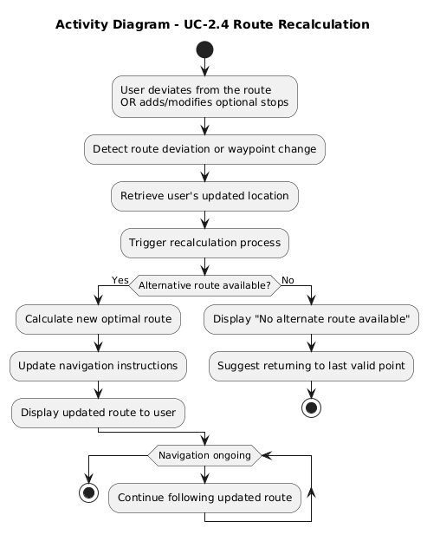
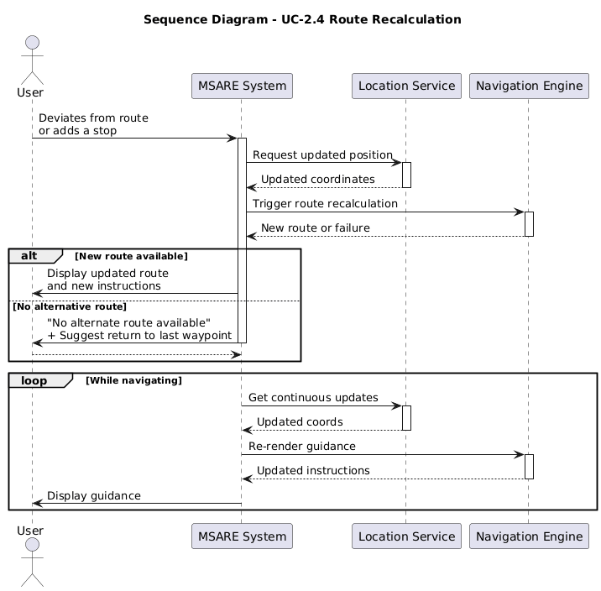
UC-2.5 Reverse Navigation — Seat → Parking
Goal:
Guide the user back to their bookmarked parking location after the match.
Preconditions:
- The user previously bookmarked their parking location.
- Indoor/outdoor positioning systems are available.
Postconditions:
- The user returns to their parked vehicle.

Main Flow:
- The user taps “Return to Parking”.
- The system retrieves the stored parking coordinates from the bookmark.
- The system determines whether the user is indoors or outdoors.
- If indoors, AR navigation is activated; if outdoors, map navigation is used.
- The system calculates the route from the seat to the bookmarked parking location.
- The system provides guidance with step-by-step instructions or AR overlays.
- The user follows the route back to the parking zone.
- The system notifies the user upon reaching the vehicle.

Alternative Flows:
A1 — Bookmark missing or deleted:
- System displays “Parking location not found” and asks user to manually select a parking zone.
A2 — Location accuracy too low:
- System prompts user to move to an open area or hold steady.

Exception Flow:
E1 — Parking location data is corrupted:
- System displays an error and removes the corrupted bookmark.
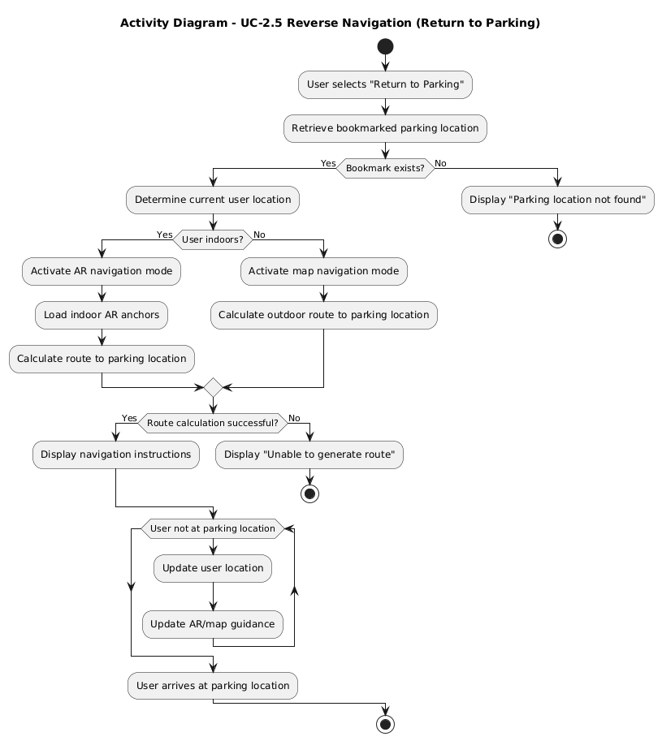
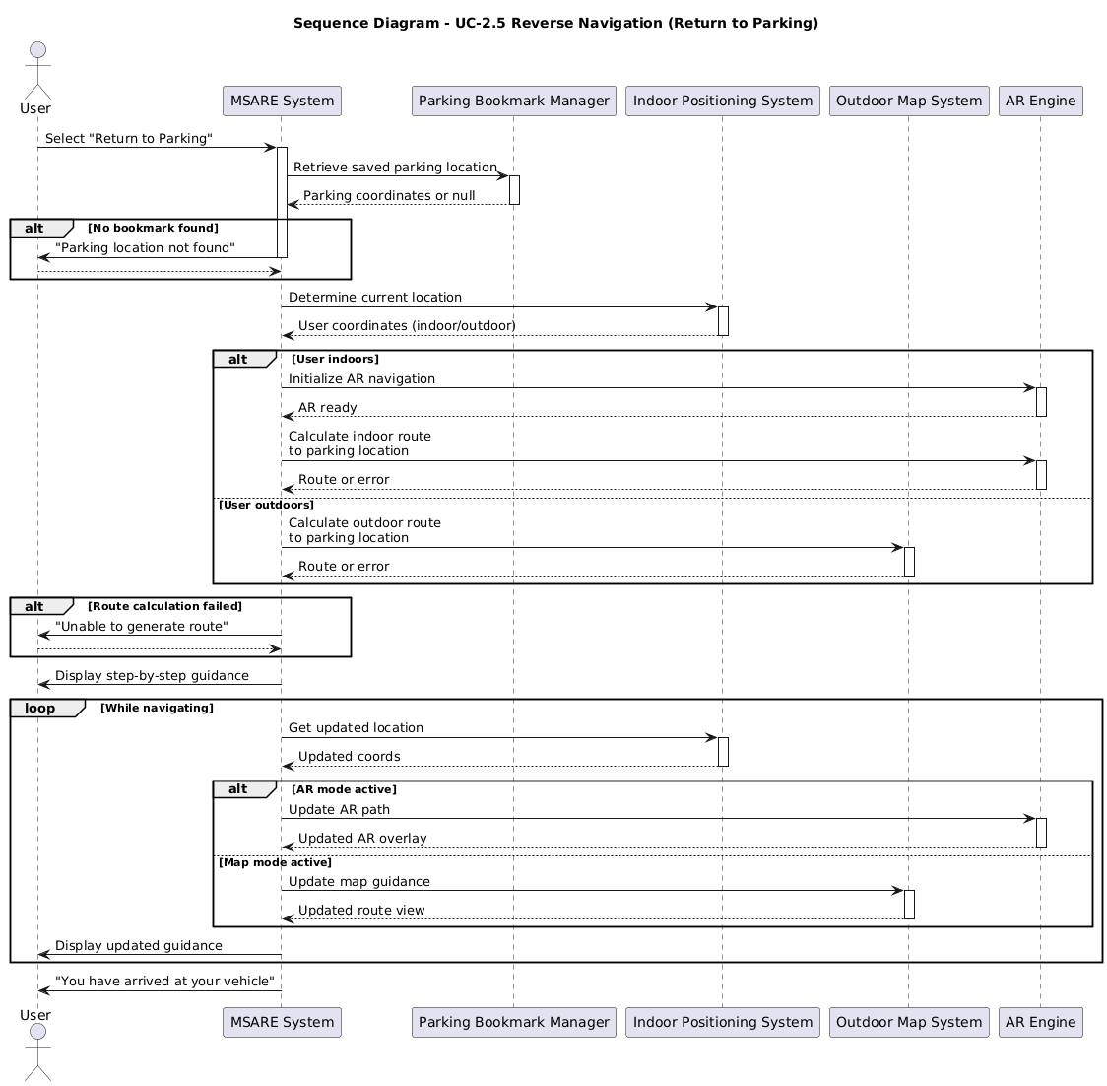
USE CASE 3 — Exit Gate Navigation
Use Case Name:
UC-3 Exit Gate Navigation
Primary Actor:
Fan (User)
Supporting Actors:
- Traffic & Congestion Data System (sensors / APIs)
- Stadium Operations System (gate metadata)

Goal:
To guide the fan to the best exit gate after the event, using real-time congestion and traffic updates, allowing both automatic suggestions and manual selection.

Preconditions:
- The fan is logged into the system.
- The fan has a valid ticket (already verified).
- Real-time or cached congestion data for exit gates is available.

Postconditions:
- The user receives a navigation route to the chosen exit gate.
- Traffic levels are displayed during navigation.
- If real-time data was not available, a distance-based gate list is still shown.

Main Flow:
- The use case begins when the user selects “Exit Navigation”.
- The system retrieves real-time congestion and traffic data for all exit gates.
- The system analyzes the data to determine the most efficient exit gate based on:
  - congestion level
  - estimated exit time
  - distance to the user’s current location
- The system displays the recommended exit gate including:
  - congestion color code (green/yellow/red)
  - estimated exit time
  - distance from current location
- The system displays all other available exit gates with their corresponding congestion levels and distances.
- The fan either accepts the recommended gate or manually selects a different gate.
- The system generates a navigation route from the fan’s current location to the selected exit gate.
- While the fan is navigating, the system periodically updates traffic data (e.g., every 15 seconds) and adjusts map colors accordingly.

Alternative Flows:
A1 — No Real-Time Traffic Data Available
Condition: at Step 2, traffic data cannot be retrieved.
- The system uses only distances to determine available exit gates.
- The system displays exit gates with distances only (no congestion colors).
- The use case resumes at Step 5 of the Main Flow.

A2 — Fan Selects a Different Exit Gate
Condition: at Step 6, the fan manually chooses a different gate.
- The system updates the selected exit gate.
- The system generates a new route to this gate.
- The use case continues from Step 7 of the Main Flow.

Exception Flow:
E1 — Unable to Generate Navigation Route
- If routing fails due to missing map data or positioning errors,
→ The system displays “Navigation unavailable” and suggests the nearest stadium landmark.
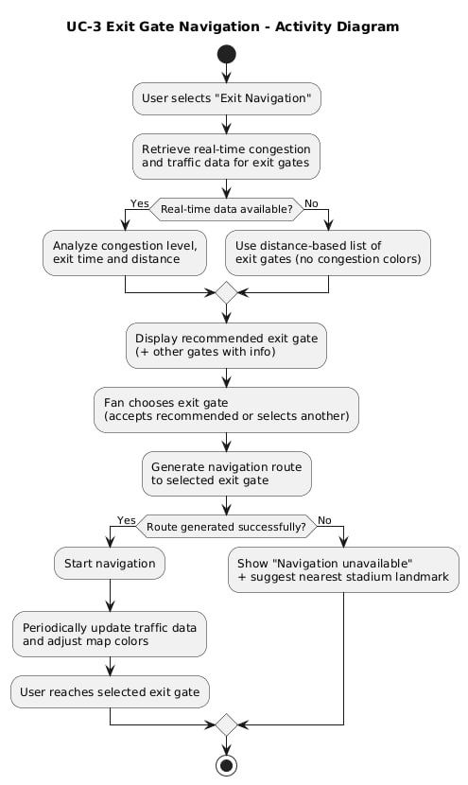
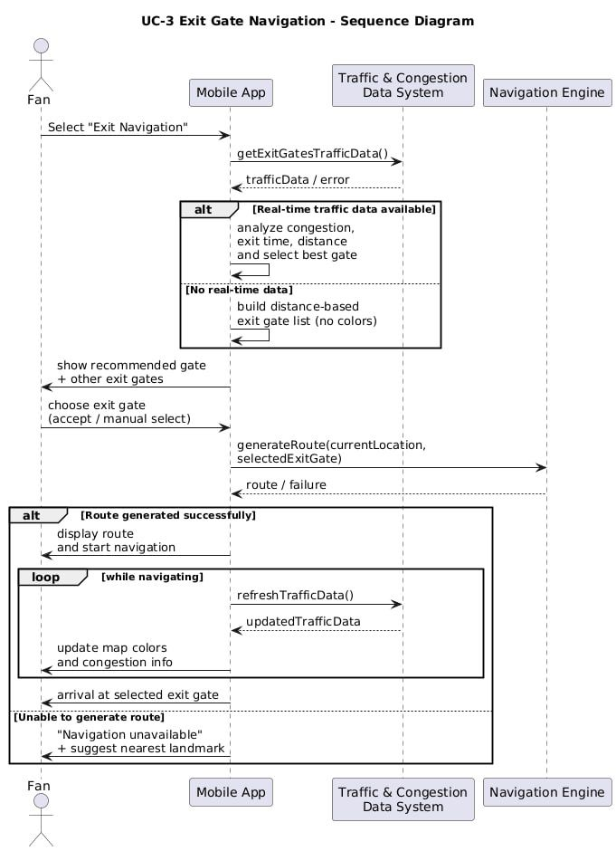
USE CASE 4 — Ticket Verification
Use Case Name:
UC-4 Ticket Verification
Primary Actor:
Fan (User)
(Gate staff can also trigger the use case when scanning physically at the entrance.)
Supporting Actors:
- Ticket Verification Service / Ticket API
- Stadium Ticketing Database

Goal:
To ensure that the fan's ticket is genuine, valid for the event, not expired, and not previously used, before granting access to the application’s features.

Preconditions:
- The user possesses a digital or physical ticket containing scannable data.
- The system is able to read the ticket information (QR, barcode, or ticket ID).
- The Ticket Verification Service or ticket API is available.

Postconditions:
- The ticket is validated and linked to the user’s active session.
- The user gains access to app features (parking, navigation, seat info).
Minimal Guarantee:
- If verification fails, the user is not allowed to proceed.

Main Flow:
- The use case begins when the user initiates “Verify Ticket”, or gate staff scans the ticket.
- The system reads the ticket data (QR code, ticket ID, metadata).
- The system sends the extracted data to the Ticket Verification Service.
- The service checks the ticket’s validity, including:
  - ticket existence
  - event/date matching
  - expiration status
  - whether it has already been used
- The service returns a Valid Ticket response.
- The system links the ticket to the user’s session, including seat and entry information.
- The system displays “Ticket Verified Successfully” and enables access to core features.

Alternative Flows:
A1 — Invalid Ticket (Non-existing, Wrong Event, or Expired)
Condition: At Step 4, ticket fails validation.
- The service returns an Invalid Ticket response.
- The system shows an error message and stops the process.

A2 — Ticket Already Used
Condition: At Step 4, ticket is flagged as “used”.
- The service returns Ticket Already Used.
- The system displays a warning message and may suggest contacting support.

A3 — Ticket API Unavailable
Condition: The system cannot reach the verification server.
- The system displays “Ticket Verification Service is unavailable, try again later.”
- Verification does not proceed and no session is created.

Exception Flow:
E1 — Ticket Data Cannot Be Scanned
- If the QR code or identifier cannot be read,
→ The system prompts the user to retry scanning or manually enter the ticket ID.
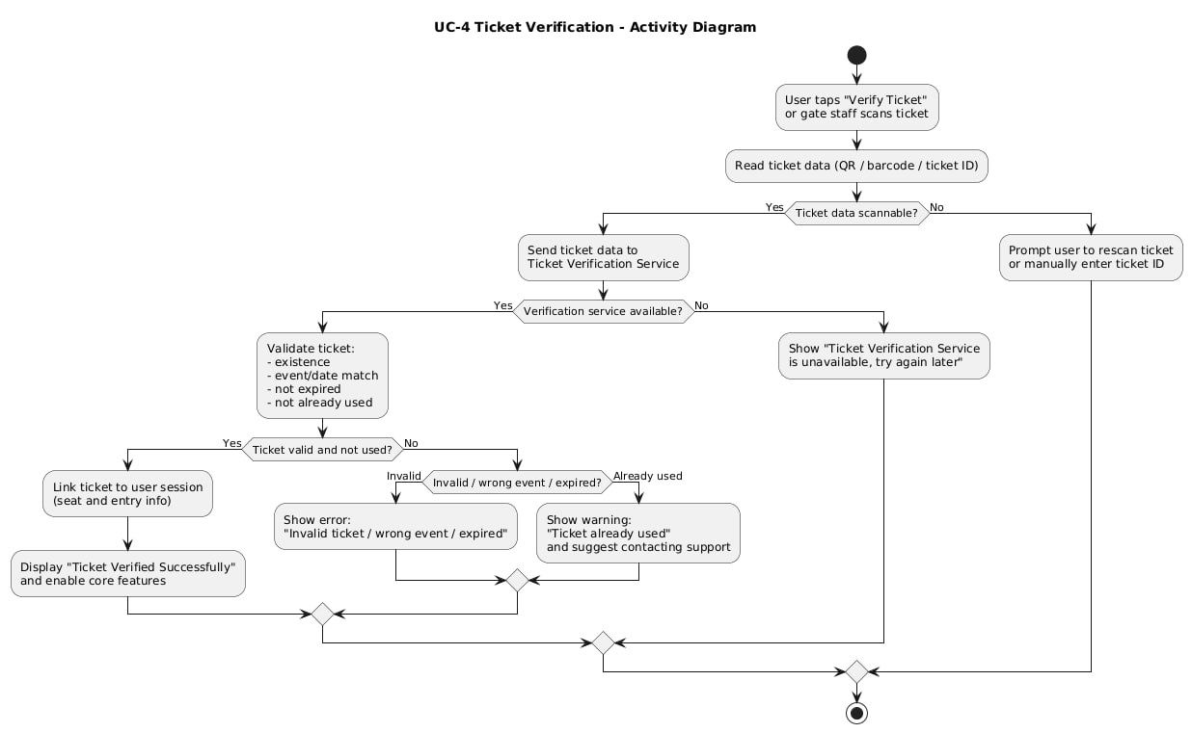
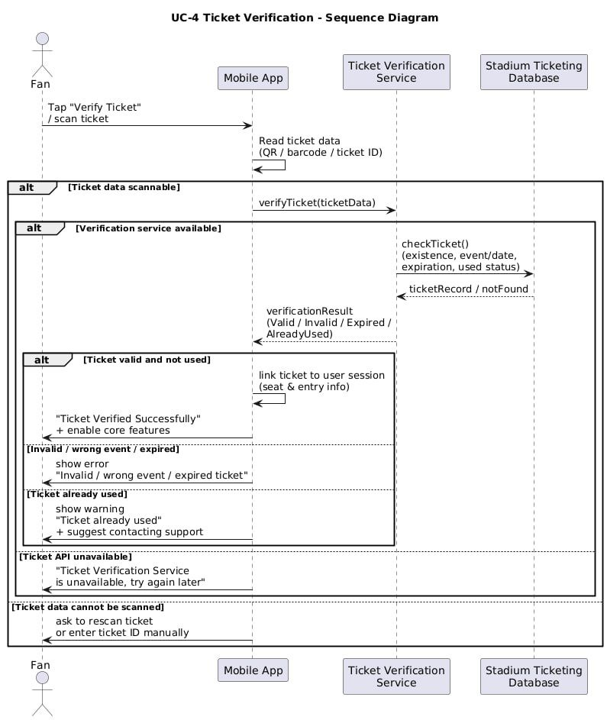
USE CASE 5 — Manage Parking Reservation Status
Use Case Name:
UC-5 Manage Parking Reservation Status
Primary Actor:
Fan (User)
Supporting Actors:
- Parking Sensors
- External Parking System (if integrated)

Goal:
To maintain accurate, real-time reservation status for each parking zone by ensuring that reservations, cancellations, and sensor-detected occupancy changes are reflected immediately and never exceed the zone’s defined capacity.

Preconditions:
- Parking zones and their capacities are preconfigured in the system.
- The fan is logged into the application.
- The reservation management module can access the reservation database.

Postconditions:
- Parking zone status (Available / Reserved / Taken) is updated correctly.
- Active reservation count does not exceed the zone’s maximum capacity.
Minimal Guarantee:
- If an error occurs, no new reservation is confirmed, and the availability counters remain unchanged.

Main Flow:
- The use case begins when the fan selects a parking zone and requests a reservation.
- The system retrieves the zone’s capacity and current number of active reservations.
- The system checks whether at least one spot is available.
- If a spot is available, the system creates a new reservation associated with the fan and the selected zone.
- The system updates the zone’s availability counters (e.g., decrease available spots).
- The system confirms the reservation and displays the updated status to the fan.
- When the fan later cancels the reservation or leaves the parking zone, the system updates the reservation status (Cancelled or Completed) and adjusts availability accordingly.

Alternative Flows:
A1 — Parking Zone Full (Over-booking Attempt)
Condition: At Step 3, no spots are available.
- The system rejects the reservation request.
- The system informs the fan that the zone is full.
- The system may suggest alternative zones.
- No changes are made to current reservations or counters.

A2 — Concurrent Reservation Conflict
Condition: Two or more users attempt to reserve the last available spot simultaneously.
- The system applies locking/transaction control to ensure only one reservation succeeds.
- The unsuccessful request receives a “Zone Full” or “Reservation Failed” message.
- No invalid or duplicate reservation is created.

A3 — Sensor Update Without User Action
Condition: Parking sensors detect a vehicle entering or leaving the zone.
- The system receives the sensor event.
- The system updates the zone status accordingly (e.g., mark spot as Taken when a car arrives, Available when it leaves).
- If no active reservation exists for the vehicle in that spot, the system adjusts availability appropriately.
- Updated status is pushed to the user interface in real time.

Exception Flow:
E1 — Database or Module Failure
- If the reservation database or zone counters cannot be updated,
→ The system aborts the reservation attempt and informs the fan of an internal error.

